English Weekly Study  Term 2 Week 2  You need to be able to read, write and spell.  Please study, revise and practise. | Name:
 | Parent Signature:
 | Completed Last Week: Yes / No
My Spelling Words | Word Types | Monday | Tuesday | Wednesday | Thursday
1. | analytical word
2. | analytical word
3. | analytical word
4. | analytical word
5. | analytical word
6. | etymological word
7. | maths word
8. | science word
9. | science word
10. | book word
11. | book word
12. | base word of morphemic word
13. | morphemic change
14. | morphemic change
Spelling Study, Say, Cover, Write, Check
Writing Add the punctuation. Then study these sentences through having someone dictate them. Staple your dictation onto the sheet.

are you running in the cross country asked ben (6)
no i cant as i broke my leg replied jenny (6)
Reading Read at least four times a week. I have read _____ out of the minimum goal of 42 .
Monday | Tuesday | Wednesday | Thursday
yes / no | yes / no | yes / no | yes / no
Comprehension Discussion After reading discuss this question to promote text understanding.
- What is the most interesting word in the text that you read?

Mathematics Answers circle, hexagon, rhombus, equilateral triangle, decagon, oval, square, kite, nonagon, parallelogram, right angled triangle, trapezium, pentagon, octagon, heptagon, rectangle
Mathematics Weekly Skill  Term 2 Week 2  This skill will be assessed on Friday.  Please study, revise and practise. |  | Name:
 |  | Parent Signature:
 |  | Skill Number 5
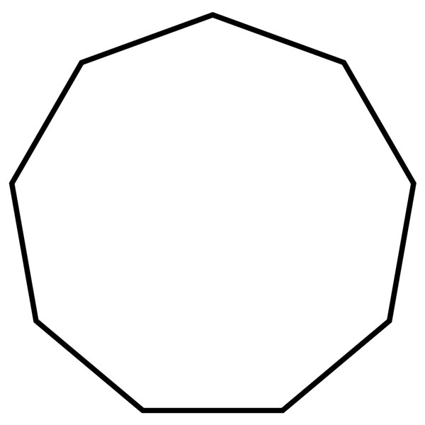
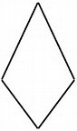

Remember: Count the number of sides

circle - equal radius or oval - unequal radius (1 side)
triangles: tri (3 sides)
quadrilaterals (4 sides) square, rectangle, rhombus, parallelogram, trapezium, kite
pentagon - penthouse (5 sided)
hexagon - x like in six (6 sided)
heptagon - heptathlon - 7 events (7 sided)
octagon - octopus - 8 legged (8 sided)
nonagon - nine - two n’s (9 sided)
decagon - decade - 10 years (10 sided)

Strand: 2D Space
Skill: Name common 2D shapes

