English Weekly Study  Term 2 Week 8  You need to be able to read, write and spell.  Please study, revise and practise. | Name:
 | Parent Signature:
 | Completed Last Week: Yes / No
My Spelling Words | Word Types | Monday | Tuesday | Wednesday | Thursday
1. | analytical word
2. | analytical word
3. | analytical word
4. | analytical word
5. | analytical word
6. | etymological word
7. | maths word
8. | history word
9. | history word
10. | book word
11. | book word
12. | base word of morphemic word
13. | morphemic change
14. | morphemic change
Spelling Study, Say, Cover, Write, Check
Writing Add the punctuation. Then study these sentences through having someone dictate them. Staple your dictation onto the sheet.

what do you think about the weather asked zayne (6)
it has definitely got colder replied hannah (6)
Reading Read at least four times a week. I have read _____ out of the minimum goal of 42 .
Monday | Tuesday | Wednesday | Thursday
yes / no | yes / no | yes / no | yes / no
Comprehension Discussion After reading discuss this question to further your thinking.
- What is your VIP from your reading? Explain your reasons to someone.

Mathematics Answers marked by teacher
Mathematics Weekly Skill  Term 2 Week 8  This skill will be assessed on Friday.  Please study, revise and practise. |  | Name:
 |  | Parent Signature:
 |  | Skill Number 6
Place the fraction on the number line.
A. First look at the denominator (bottom number in a fraction) and divide the number line into the required equal shares. With a third, three equal parts are needed.
0
1

B. Next look at the numerator (top number in a fraction) move along the line from zero until the number of shares have been matched. In this example it will be one.
1
0

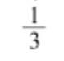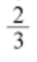
Remember:
* Must have equal shares!!!!!! Show your fair shares.
Put these fractions on the number lines: 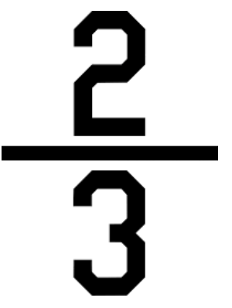, 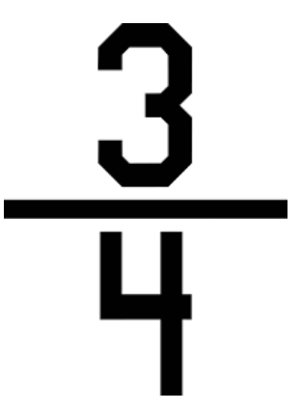, , 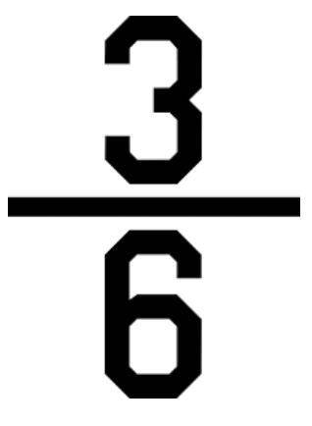
0
1

1
0

0
1

0
1

Substrand: Fractions and Decimals
Skill: Placing a fraction on a number line

