Weeks 10 and 11 – 2-6A /Iguanas and Lemurs Group
 | Monday | Tuesday | Wednesday | Thursday | Friday
Morning | ENGLISH  Read reader + complete a page of Iggy Peck workbook+ practice sight words+ 1 page sight word sentences booklet  Spelling contract ( complete one column of tracing plus one activity page of weekly booklet)  Handwriting- one page  Take Home Journal – write about your weekend  Morning Work Booklet- one page | ENGLISH  Read reader + complete a page of Iggy Peck workbook+ practice sight words+1 page sight word sentences booklet  Spelling contract  Handwriting- one page  Take Home Activity Pack – describe your favourite place in your home  Morning Work Booklet- one page | ENGLISH  Read reader + complete a page of Iggy Peck workbook+ practice sight words+1 page sight word sentences booklet  Spelling contract  Handwriting- one page  Take Home Activity Pack – Watch BTN and write a summary  Morning Work Booklet- one page | ENGLISH  Read reader + complete a page of Iggy Peck workbook+ practice sight words+1 page sight word sentences booklet  Spelling contract  Handwriting- one page  Take Home Activity Pack – write a sizzling start ( theme: waterpark)  Morning Work Booklet- one page | ENGLISH  Read reader + complete a page of Iggy Peck workbook+ practice sight words+1 page sight word sentences booklet  Spelling test  Handwriting- one page  Take Home Activity Pack – Stretch this sentence: The dog barked.  Morning Work Booklet- one page
Break | Break https://standupkids.org/movement-break/ ( choose one) | Break https://app.gonoodle.com/ ( choose one) | Break – Just Dance https://www.youtube.com/channel/UChIjW4BWKLqpojTrS_tX0mg | Break- keep a balloon alight for 20 hits | Break – play quoits-throw a paper plate_ insert cut out) to loop an empty paper towel tube standing up in playdough
Middle | MATHEMATICS  Whole Number- Practise counting forwards and backwards by ones from 23  Time Booklet- one page  Numeracy /Number Work Booklet – one page  I Can Add Booklet – one page  Basic Maths Facts | MATHEMATICS  Whole Number- Practise counting forwards and backwards by ones from 44  Money Booklet – one page  Numeracy /Number Work Booklet – one page  That Spring Feeling Booklet – one page  Basic Maths Facts | MATHEMATICS  Whole Number- Practise counting forwards and backwards by ones from 12  Time Booklet- one page  Numeracy /Number Work Booklet – one page  I Can Add Booklet – one page  Basic Maths Facts | MATHEMATICS  Whole Number- Practise counting forwards and backwards by ones from 59  Money Booklet – one page  Numeracy /Number Work Booklet – one page  Data Booklet- one activity  Basic Maths Facts | MATHEMATICS  Whole Number- Practise counting forwards and backwards by ones from 38  Time Booklet- one page  Money Booklet – one page  Numeracy /Number Work Booklet – one page  I Can Add Booklet – one page  Basic Maths Facts
Break | Break + 50 star jumps | Break + 50 burpees | Break + 50 squats | Break + kick ball against the wall for 10 minutes | Break + Practise throwing a ball against the wall and catching it.
Afternoon | CREATIVE ARTS  Week 10: create a lemur-cut, paste and decorate with coloured crepe paper  Week 11: https://www.danyabanya.com/sydney-harbour-bridge-craft/  Make a replica of the Harbour Bridge using coffee cups and a paper plate.  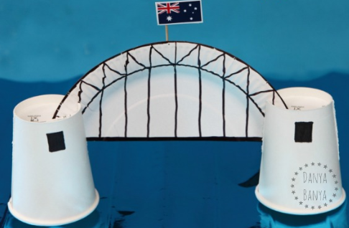 | SCIENCE AND TECHNOLOGY  Week 10: go on a scavenger hunt in the garden for signs of life- draw the insect/animal discovered and label it. 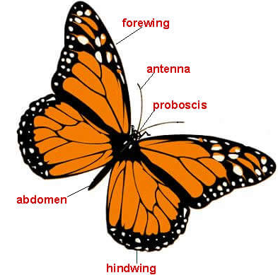  Week 11:  Complete the straw/toothpicks experiment with your child ( please find it in plastic sleeve) | PDH  Week 10: Draw faces to show the different emotions we experience- add mouths and eyebrows to show the emotion on each face then label each with the emotion represented.  Week 11:  Discuss and name some strong feelings. Identify which ones make us feeling good and energised. Which ones leave us tired and feeling bad about ourselves? Look at the Zones Tools Menu and discuss the things we can do to help when we feel strong emotions. | STEM  Week 10: use some recycled boxes at home to build a structure that is stable and can balance a piece of fruit on top. Draw a picture of it in journal and label it. Write a sentence stating what helped make your structure remain stable or what caused it to topple and what you could do differently next time.  Week 11:  Challenge: Build a strong tower  Materials: stack of paper from recycling; pile of books  Instructions: Build a tower that will hold as many books as possible, at least 15 cm off the ground.  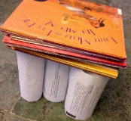  ( Hopefully students will recall that columns are strong structures)  Hint: | PE  Week 10: Play a game of French cricket together.  Week 11:  Obstacle course: Create a furniture course in your house or take chalk outside and make a course. Have your child navigate his way through it.

